1-TOPSHIRIQ 6-variant
1-masala:
def farzin_yurishi(x1, y1, x2, y2):
if x1 == x2 or y1 == y2 or abs(x2 - x1) == abs(y2 - y1):
return True
else:
return False
x1 = int(input("x1 (1-8): "))
y1 = int(input("y1 (1-8): "))
x2 = int(input("x2 (1-8): "))
y2 = int(input("y2 (1-8): "))
if farzin_yurishi(x1, y1, x2, y2):
print("Farzin bir yurishda o'ta oladi.")
else:
print("Farzin bir yurishda o'ta olmaydi.")
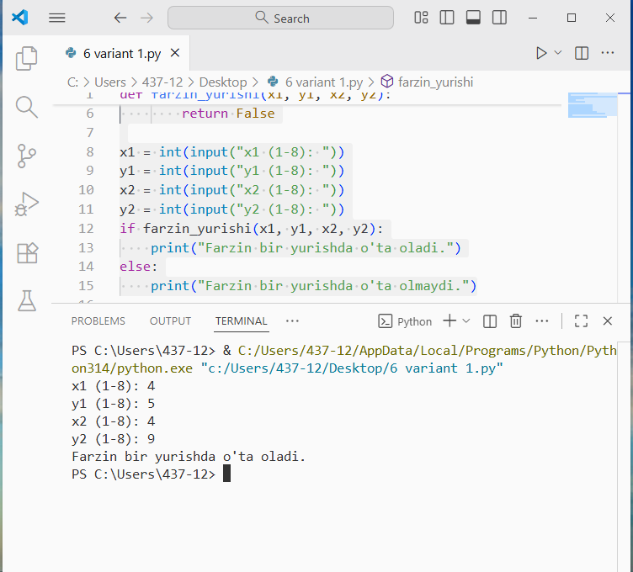

2-masala:
n = int(input("n ni kiriting (n > 0): "))
a = float(input("a ni kiriting (haqiqiy son): "))
for i in range(1, n+1):
daraja = a ** i
print(f"{a}^{i} = {daraja}")
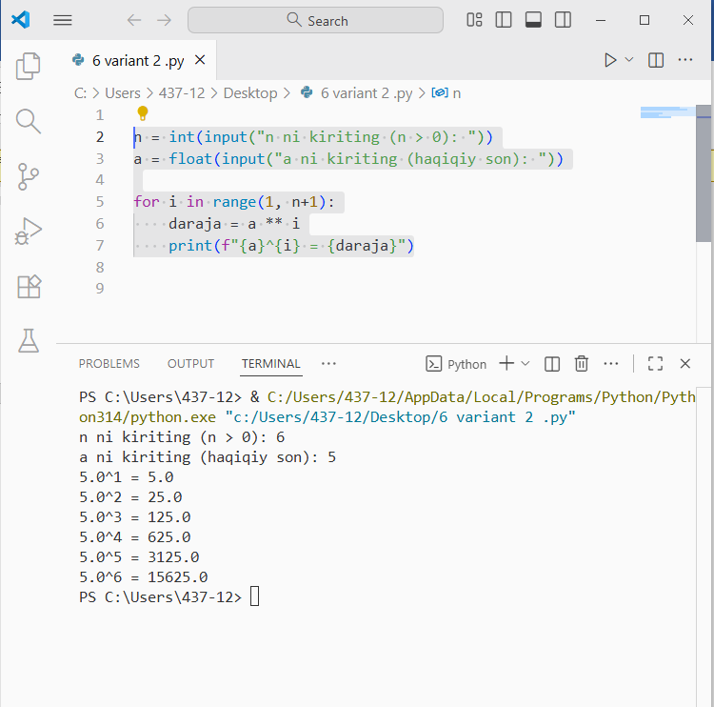

3-masala:
satr=str(input("satr kiriting:"))
yangi_satr=(" ").join(satr)
print(yangi_satr)
